CS405 - Emre Bülbül – 28882 - Project 1

All operations were performed by the order in the prompt.

( translation:

0.3 units in x-axis

-0.25 units in y-axis

scaling:

0.5 by x-axis

0.5 by y-axis

rotation:

30 degrees on x-axis

45 degrees on y-axis

60 degrees on z-axis

)

TASK 1:

<https://chat.openai.com/share/e83d2456-bf11-4e39-b14b-66d3cf15e69d>



const transformationMatrix = new Float32Array([

0.3535533845424652, 0.6123724575042725, 0.7071067690849304, 0,

-0.25, 0.4330127239227295, -0.5, 0,

-0.6123724575042725, 0.3535533845424652, 0.7071067690849304, 0,

0.3, -0.25, 0, 1

]);

Chat provides transformationMatrix as above,

TASK 2:

Since all of the needed functions (matrix multiplication, identity, scaling, translation, rotation matrixes) are provided by you, I applied every transformation and then multiplied accordingly.

// Start with the identity matrix

var modelViewMatrix = createIdentityMatrix();

// Apply translation

var translationMatrix = createTranslationMatrix(0.3, -0.25, 0);

modelViewMatrix = multiplyMatrices(modelViewMatrix, translationMatrix);

// Apply scaling

var scalingMatrix = createScaleMatrix(0.5, 0.5, 1);

modelViewMatrix = multiplyMatrices(modelViewMatrix, scalingMatrix);

// Apply rotation

var rotationXMatrix = createRotationMatrix_X(degreesToRadians(30));

var rotationYMatrix = createRotationMatrix_Y(degreesToRadians(45));

var rotationZMatrix = createRotationMatrix_Z(degreesToRadians(60));

modelViewMatrix = multiplyMatrices(modelViewMatrix, rotationXMatrix);

modelViewMatrix = multiplyMatrices(modelViewMatrix, rotationYMatrix);

modelViewMatrix = multiplyMatrices(modelViewMatrix, rotationZMatrix);

console.log(modelViewMatrix);

return modelViewMatrix;

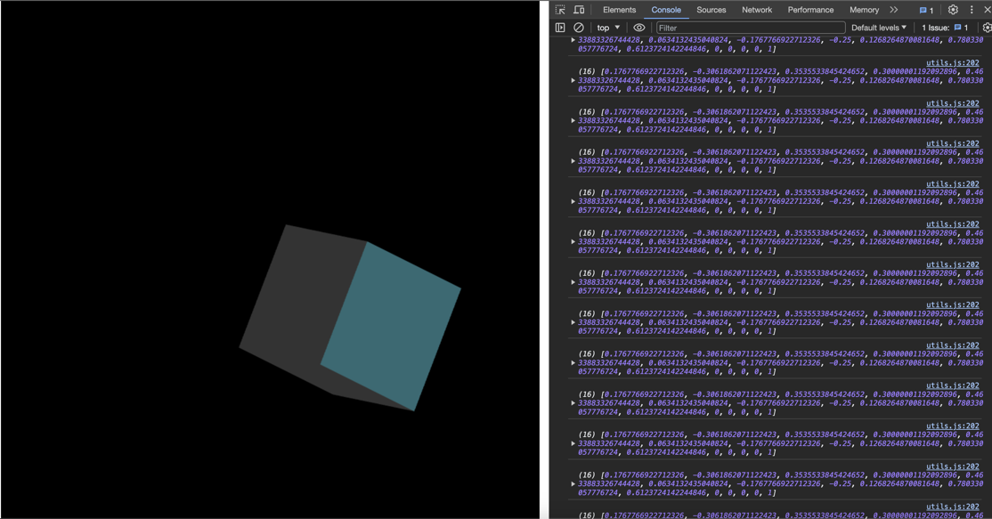

As it can be seen from the console.log by doing calculations by utilizing JavaScript I get something like  
[

0.1767766922712326,-0.3061862071122423,0.3535533845424652,0.30000001192092896,

0.4633883326744428,0.0634132435040824,-0.1767766922712326,-0.25,

0.1268264870081648,0.780330057776724,0.6123724142244846,0,

0,0,0,1

]

Difference between my matrix and ChatGPT’s matrix probably resulting from ChatGPT’s calculation skills. ChatGPT’s calculation skills are not that well so that it may be having wrong result because it cannot calculate well in the background. I do think that utilizing functions in JavaScript that you provided is more reliable and accurate.

TASK 3:

<https://chat.openai.com/share/89781b4a-dff7-419c-860d-6e2326554757>

While I was creating the animation, all I did was creating same things as I did before in TASK 2, but to smooth the operations as ChatGPT suggested I’ve added progress for each transformation I done. In addition, I’ve put

if (currentTime >= 5 && currentTime < 6) {

console.log("Matrix at 5th second:");

console.log(getModelViewMatrix());

}

Part to check whether it is matching with the matrix in TASK 2.

// Calculate the progress of the animation (value between 0 and 1)

var animationProgress = (currentTime % animationDuration) / animationDuration;

// Determine whether to apply forward or reverse transformations

var isForward = animationProgress <= 0.5;

// Adjust progress for the reverse transformations

if (!isForward) {

animationProgress = 1 - animationProgress; // Reverse the progress

}

This part is the part that Total duration is 10s and half of it is 5s so that it should be reversed after 5th second this part of the code checks it and reverses it.

// Helper function to convert degrees to radians

function degreesToRadians(degrees) {

return degrees * (Math.PI / 180);

}

There is a helper function for converting degrees to radians (it is also used in task2).

FINAL VERSION:

